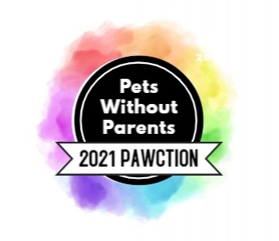
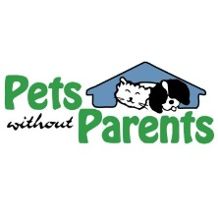
EVENT SUPPORTER FORM

Pawction is an annual fundraiser filled with good food, drinks, great people and of course, incredible art and prize packages. 100% of the proceeds will go directly to Pets Without Parents, Central Ohio’s only true no-kill, all-breed, dog and cat shelter.

Sunday, October 10th, 2021
1PM – 4PM
Strongwater Food & Spirits

Company Name (if applicable):
Contact Person:
Address:
Email: Phone:

We would like to be an event sponsor! Please select an option below:

PLATINUM PAW | $1,500:
Opportunity to speak at the event, Verbal recognition at the event, Name/Logo in media publicity, Top level logo placement in print advertising, Social media recognition as TITLE SPONSOR on Pets Without Parents social media accounts, Top level logo placement in email advertisements, Top level logo placement on event website with link to company website, 6 tickets to the event

GOLD PAW | $1,000:
Logo placement in print advertising, Social media recognition on Pets Without Parents social media accounts, Logo placement in email advertisements, Logo placement on event website with link to company website, 4 tickets to the event

SILVER PAW | $500:
Name placement in print advertising, Social media recognition on Pets Without Parents social media accounts, Logo placement in email advertisements, Name placement on event website, 2 tickets to the event

BRONZE PAW | $300:
Name placement in email advertisements, Name placement on event website, 1 ticket to the event

OTHER AMOUNT: $

We would like to donate (prize for silent auction, swag bag items, etc)!
Item Description: | Retail Value:

*All sponsorship promotions are dependent upon timing of sponsorship commitment and payment! The sooner you commit the more advertising you get! Pets Without Parents is a 501c3 non-profit organization. Donations are tax deductible as allowed by law. Complimentary tickets to the event are not tax deductible. For your records, our Fed ID # is 31-1771246.
Thank you for your support and generosity!
Please email completed form to pwpboard@gmail.com or mail to Pets Without Parents, 629 Oakland Park Ave., Columbus, OH 43214. Payment can be made via check payable to Pets Without Parents or online at www.petswithoutparents.net/donate (please note “Pawction Sponsor” in comments). If donating an item, please email pwpboard@gmail.com to arrange pickup.

